1. Create A Simple User Registration Form Using Awt In Java Which Has The Fields likes FirstName, Last-Name, Date Of Birth, Gender – Male Or Female(Check box Or Radio Button), Place ,Contact Number and Submit button

package com.challengeawtswing;

import java.awt.*;

import java.awt.event.*;

import javax.swing.JOptionPane;

public class UserRegistrationForm extends Frame implements ActionListener {

private Label firstNameLabel, lastNameLabel, dobLabel, genderLabel, placeLabel, contactLabel;

private TextField firstNameField, lastNameField, dobField, placeField, contactField;

private CheckboxGroup genderCheckboxGroup;

private Checkbox maleCheckbox, femaleCheckbox;

private Button submitButton;

public UserRegistrationForm() {

setLayout(new GridLayout(8, 2)); // 8 rows, 2 columns

firstNameLabel = new Label("First Name:");

lastNameLabel = new Label("Last Name:");

dobLabel = new Label("Date of Birth (YYYY-MM-DD):");

genderLabel = new Label("Gender:");

placeLabel = new Label("Place:");

contactLabel = new Label("Contact Number:");

firstNameField = new TextField(20);

lastNameField = new TextField(20);

dobField = new TextField(20);

placeField = new TextField(20);

contactField = new TextField(20);

genderCheckboxGroup = new CheckboxGroup();

maleCheckbox = new Checkbox("Male", genderCheckboxGroup, false);

femaleCheckbox = new Checkbox("Female", genderCheckboxGroup, false);

submitButton = new Button("Submit");

submitButton.addActionListener(this);

add(firstNameLabel);

add(firstNameField);

add(lastNameLabel);

add(lastNameField);

add(dobLabel);

add(dobField);

add(genderLabel);

add(maleCheckbox);

add(new Label("")); // Empty label for spacing

add(femaleCheckbox);

add(placeLabel);

add(placeField);

add(contactLabel);

add(contactField);

add(new Label("")); // Empty label for spacing

add(submitButton);

setTitle("User Registration Form");

setSize(400, 300);

setVisible(true);

addWindowListener(new WindowAdapter() {

public void windowClosing(WindowEvent e) {

dispose();

}

});

}

public void actionPerformed(ActionEvent e) {

if (e.getSource() == submitButton) {

String firstName = firstNameField.getText();

String lastName = lastNameField.getText();

String dob = dobField.getText();

String gender = (maleCheckbox.getState() ? "Male" : "Female");

String place = placeField.getText();

String contact = contactField.getText();

// Here you can write your logic to handle the form data

// For example, saving to a database or displaying a message dialog

// For now, let's just display a message dialog

String message = "Registration Successful!\nThank you, " + firstName + " " + lastName + "!";

JOptionPane.*showMessageDialog*(this, message, "Registration Successful", JOptionPane.***INFORMATION_MESSAGE***);

// Clear fields after submission

firstNameField.setText("");

lastNameField.setText("");

dobField.setText("");

genderCheckboxGroup.setSelectedCheckbox(null); // Clear gender selection

placeField.setText("");

contactField.setText("");

}

}

public static void main(String[] args) {

new UserRegistrationForm();

}

}

Output:

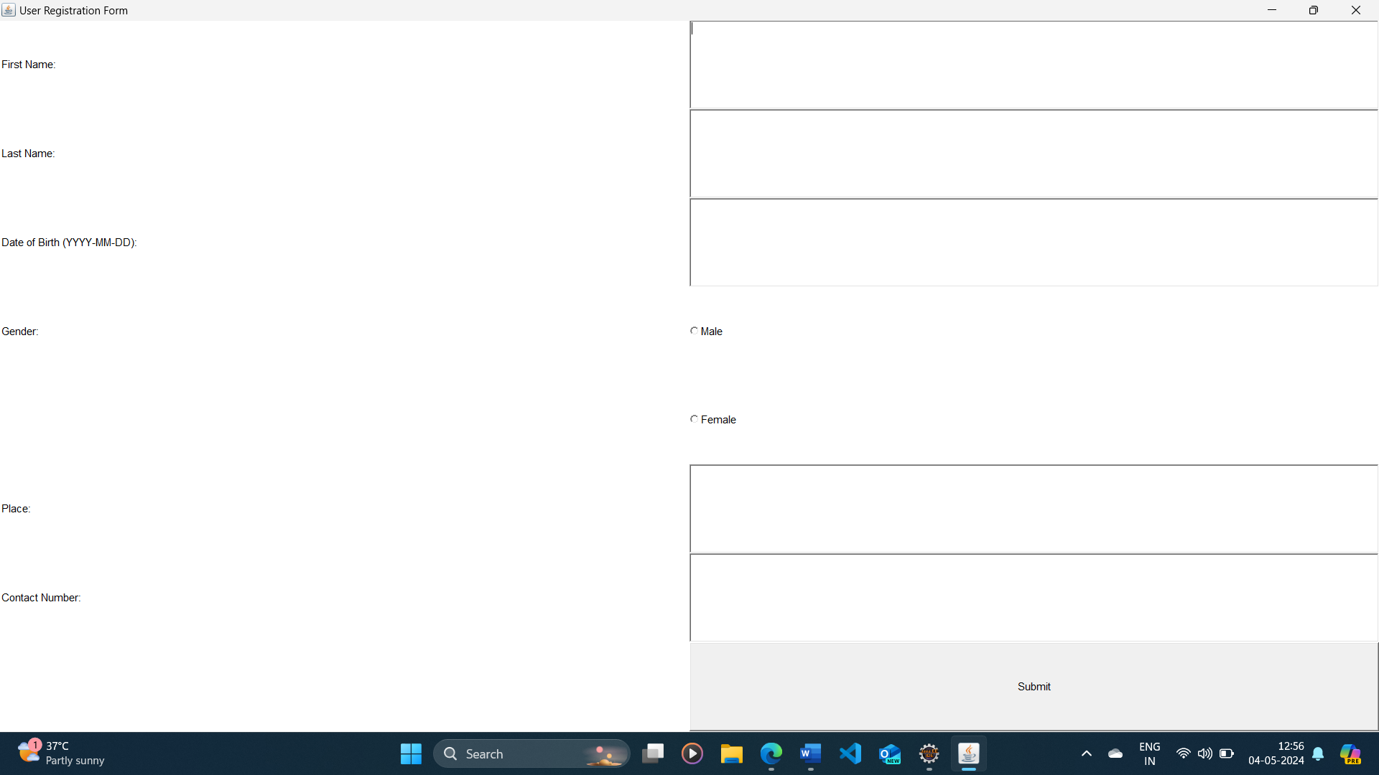

2. How To Make A Simple Calculator Using AWT & Swing In Java

package com.challengeawtswing;

import javax.swing.*;

import java.awt.*;

import java.awt.event.*;

public class SimpleCalculator extends JFrame implements ActionListener {

private JTextField display;

private JButton[] buttons;

private String[] buttonLabels = {

"7", "8", "9", "/", // Row 1

"4", "5", "6", "*", // Row 2

"1", "2", "3", "-", // Row 3

"0", ".", "=", "+" // Row 4

};

private double num1, num2;

private char operator;

public SimpleCalculator() {

setTitle("Simple Calculator");

setSize(300, 300);

setDefaultCloseOperation(JFrame.***EXIT_ON_CLOSE***);

display = new JTextField(10);

display.setEditable(false);

add(display, BorderLayout.***NORTH***);

JPanel buttonPanel = new JPanel();

buttonPanel.setLayout(new GridLayout(4, 4, 5, 5));

buttons = new JButton[buttonLabels.length];

for (int i = 0; i < buttonLabels.length; i++) {

buttons[i] = new JButton(buttonLabels[i]);

buttons[i].addActionListener(this);

buttonPanel.add(buttons[i]);

}

add(buttonPanel, BorderLayout.***CENTER***);

setVisible(true);

}

public void actionPerformed(ActionEvent e) {

String command = e.getActionCommand();

if (Character.*isDigit*(command.charAt(0)) || command.equals(".")) {

display.setText(display.getText() + command);

} else if (command.equals("=")) {

num2 = Double.*parseDouble*(display.getText());

double result = calculate(num1, num2, operator);

display.setText(String.*valueOf*(result));

} else {

num1 = Double.*parseDouble*(display.getText());

operator = command.charAt(0);

display.setText("");

}

}

private double calculate(double num1, double num2, char operator) {

switch (operator) {

case '+':

return num1 + num2;

case '-':

return num1 - num2;

case '*':

return num1 * num2;

case '/':

if (num2 != 0)

return num1 / num2;

else

return 0;

default:

return 0;

}

}

public static void main(String[] args) {

SwingUtilities.*invokeLater*(new Runnable() {

public void run() {

new SimpleCalculator();

}

});

}

}

Output:

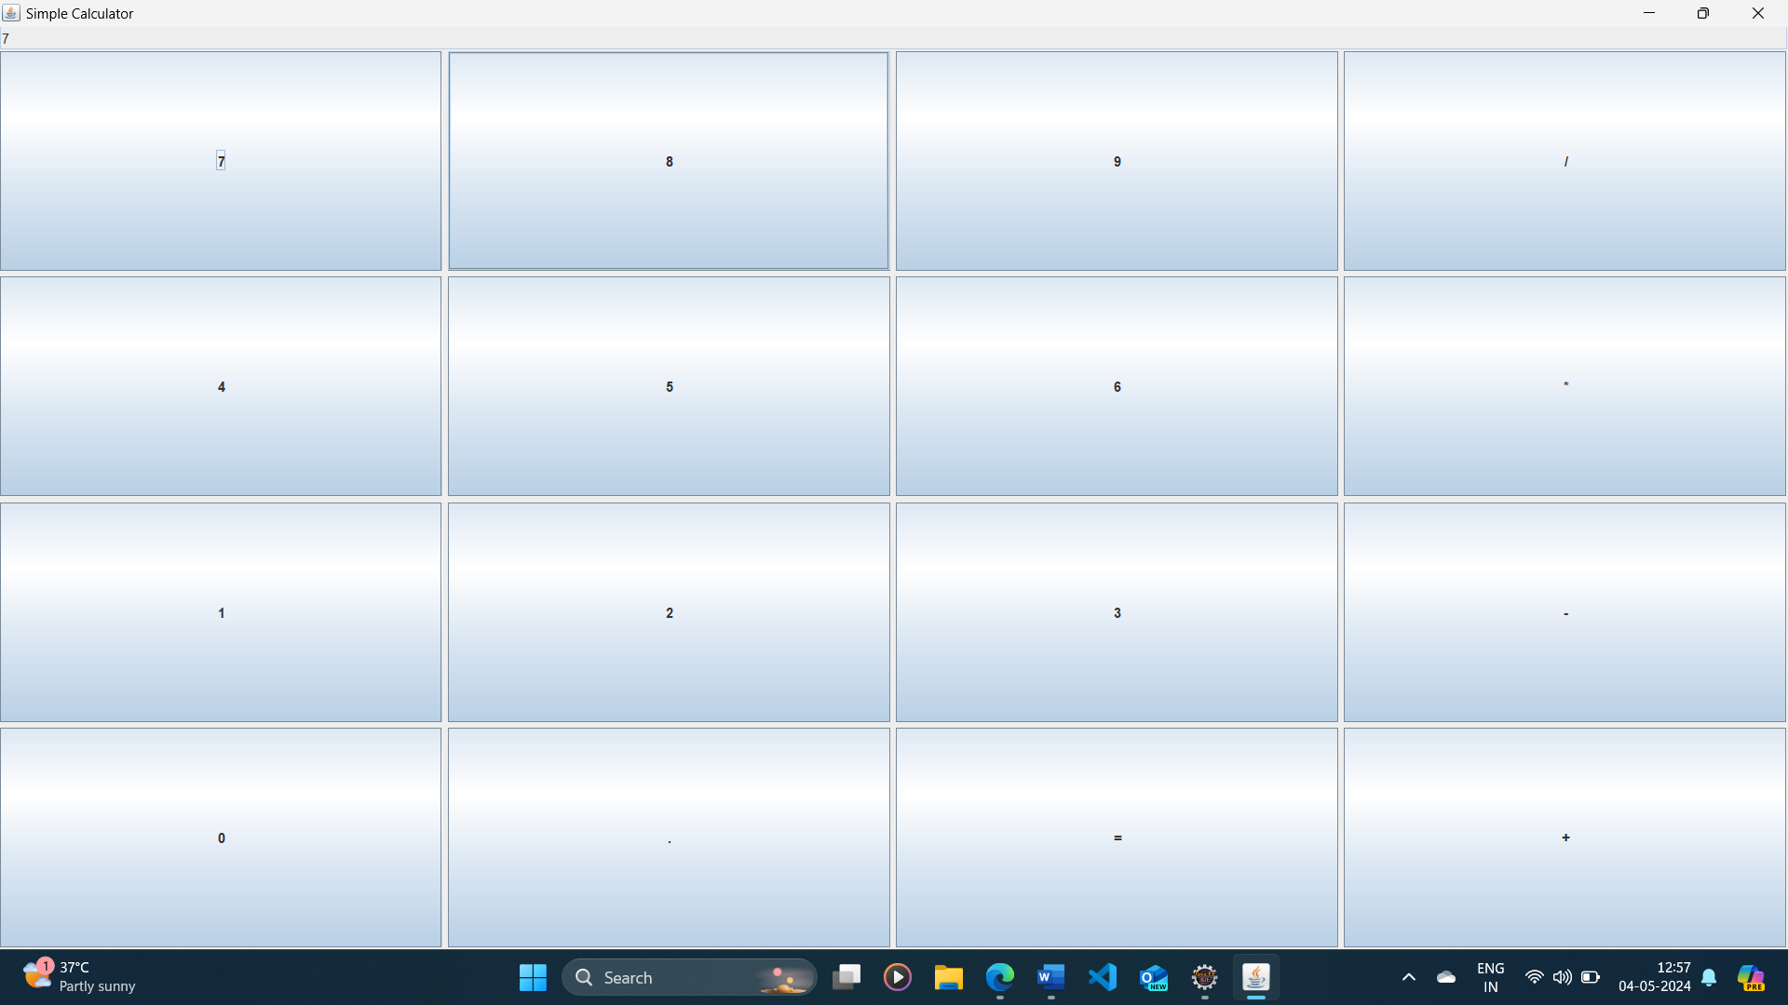

3. How To Create A Simple Notepad In Java Using Swing application

package com.challengeawtswing;

import javax.swing.*;

import java.awt.*;

import java.awt.event.*;

import java.io.*;

public class SimpleNotepad extends JFrame {

private JTextArea textArea;

private JFileChooser fileChooser;

public SimpleNotepad() {

setTitle("Simple Notepad");

setSize(800, 600);

setDefaultCloseOperation(JFrame.***EXIT_ON_CLOSE***);

textArea = new JTextArea();

JScrollPane scrollPane = new JScrollPane(textArea);

add(scrollPane, BorderLayout.***CENTER***);

JMenuBar menuBar = new JMenuBar();

setJMenuBar(menuBar);

JMenu fileMenu = new JMenu("File");

menuBar.add(fileMenu);

JMenuItem newMenuItem = new JMenuItem("New");

fileMenu.add(newMenuItem);

newMenuItem.addActionListener(new ActionListener() {

public void actionPerformed(ActionEvent e) {

textArea.setText(""); // Clear the text area

}

});

JMenuItem openMenuItem = new JMenuItem("Open");

fileMenu.add(openMenuItem);

openMenuItem.addActionListener(new ActionListener() {

public void actionPerformed(ActionEvent e) {

openFile(); // Open a file

}

});

JMenuItem saveMenuItem = new JMenuItem("Save");

fileMenu.add(saveMenuItem);

saveMenuItem.addActionListener(new ActionListener() {

public void actionPerformed(ActionEvent e) {

saveFile(); // Save the current text to a file

}

});

JMenuItem exitMenuItem = new JMenuItem("Exit");

fileMenu.add(exitMenuItem);

exitMenuItem.addActionListener(new ActionListener() {

public void actionPerformed(ActionEvent e) {

System.*exit*(0); // Exit the application

}

});

setVisible(true);

}

private void openFile() {

if (fileChooser == null) {

fileChooser = new JFileChooser();

}

int returnVal = fileChooser.showOpenDialog(this);

if (returnVal == JFileChooser.***APPROVE_OPTION***) {

File file = fileChooser.getSelectedFile();

try {

FileReader fileReader = new FileReader(file);

BufferedReader reader = new BufferedReader(fileReader);

textArea.read(reader, null);

reader.close();

fileReader.close();

} catch (IOException ex) {

ex.printStackTrace();

JOptionPane.*showMessageDialog*(this, "Error opening file", "Error", JOptionPane.***ERROR_MESSAGE***);

}

}

}

private void saveFile() {

if (fileChooser == null) {

fileChooser = new JFileChooser();

}

int returnVal = fileChooser.showSaveDialog(this);

if (returnVal == JFileChooser.***APPROVE_OPTION***) {

File file = fileChooser.getSelectedFile();

try {

FileWriter fileWriter = new FileWriter(file);

textArea.write(fileWriter);

fileWriter.close();

} catch (IOException ex) {

ex.printStackTrace();

JOptionPane.*showMessageDialog*(this, "Error saving file", "Error", JOptionPane.***ERROR_MESSAGE***);

}

}

}

public static void main(String[] args) {

SwingUtilities.*invokeLater*(new Runnable() {

public void run() {

new SimpleNotepad();

}

});

}

}

Output:

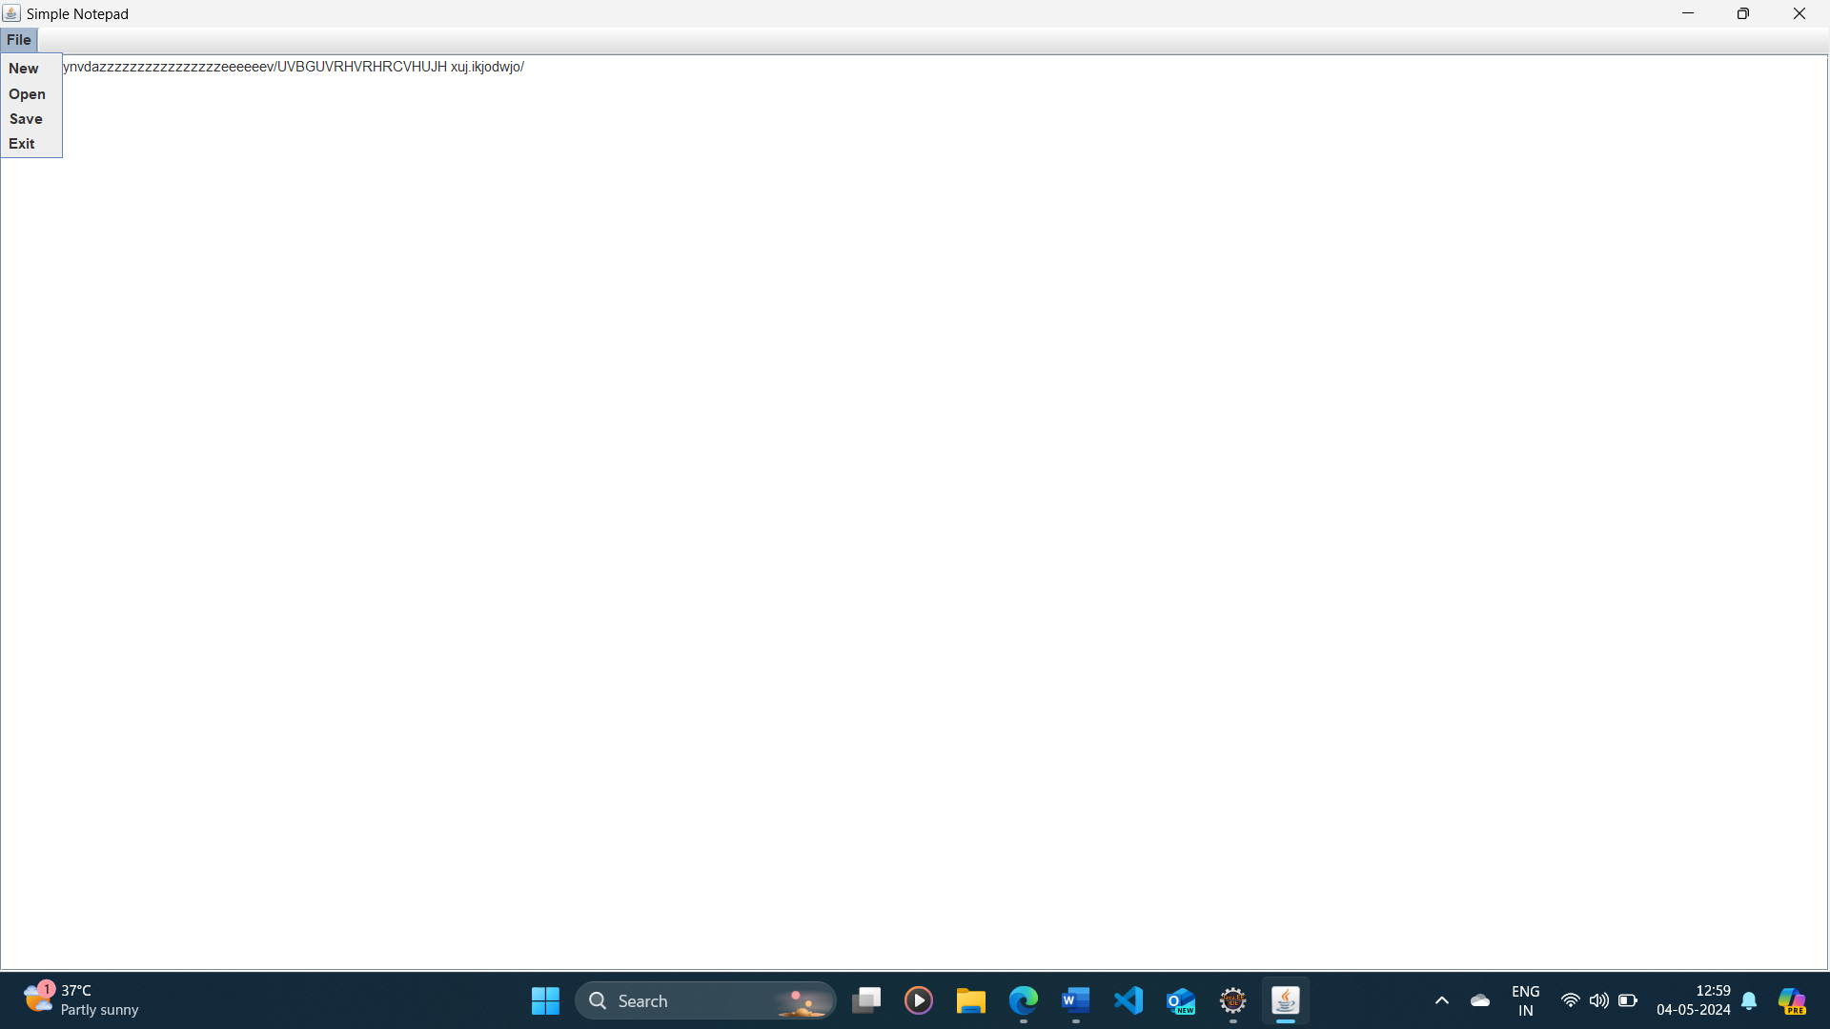

4. Create A Banking Application using Swings In java

import javax.swing.*;

import java.awt.*;

import java.awt.event.*;

import java.util.ArrayList;

import java.util.List;

public class BankingApplication extends JFrame {

private JPanel loginPanel, homePanel, createAccountPanel, viewCustomersPanel;

private JTextField usernameField;

private JPasswordField passwordField;

private JTextArea customerListArea;

private List<Customer> customers;

public BankingApplication() {

setTitle("Banking Application");

setSize(800, 600);

setDefaultCloseOperation(JFrame.***EXIT_ON_CLOSE***);

customers = new ArrayList<>();

// Initialize panels

loginPanel = new JPanel();

homePanel = new JPanel();

createAccountPanel = new JPanel();

viewCustomersPanel = new JPanel();

setupLoginPanel();

setupHomePanel();

setupCreateAccountPanel();

setupViewCustomersPanel();

add(loginPanel);

setVisible(true);

}

private void setupLoginPanel() {

loginPanel.setLayout(new GridLayout(3, 2));

JLabel usernameLabel = new JLabel("Username:");

usernameField = new JTextField();

JLabel passwordLabel = new JLabel("Password:");

passwordField = new JPasswordField();

JButton loginButton = new JButton("Login");

loginButton.addActionListener(new ActionListener() {

public void actionPerformed(ActionEvent e) {

String username = usernameField.getText();

String password = new String(passwordField.getPassword());

if (username.equals("admin") && password.equals("admin")) {

// Login successful, switch to home panel

getContentPane().removeAll();

add(homePanel);

revalidate();

} else {

JOptionPane.*showMessageDialog*(loginPanel, "Invalid username or password", "Error", JOptionPane.***ERROR_MESSAGE***);

}

}

});

loginPanel.add(usernameLabel);

loginPanel.add(usernameField);

loginPanel.add(passwordLabel);

loginPanel.add(passwordField);

loginPanel.add(new JLabel()); // Empty label for spacing

loginPanel.add(loginButton);

}

private void setupHomePanel() {

homePanel.setLayout(new GridLayout(3, 1));

JButton createAccountButton = new JButton("Create Account");

createAccountButton.addActionListener(new ActionListener() {

public void actionPerformed(ActionEvent e) {

getContentPane().removeAll();

add(createAccountPanel);

revalidate();

}

});

JButton viewCustomersButton = new JButton("View All Customers");

viewCustomersButton.addActionListener(new ActionListener() {

public void actionPerformed(ActionEvent e) {

updateCustomerList();

getContentPane().removeAll();

add(viewCustomersPanel);

revalidate();

}

});

JButton logoutButton = new JButton("Logout");

logoutButton.addActionListener(new ActionListener() {

public void actionPerformed(ActionEvent e) {

getContentPane().removeAll();

add(loginPanel);

revalidate();

}

});

homePanel.add(createAccountButton);

homePanel.add(viewCustomersButton);

homePanel.add(logoutButton);

}

private void setupCreateAccountPanel() {

createAccountPanel.setLayout(new GridLayout(4, 2));

JLabel nameLabel = new JLabel("Name:");

JTextField nameField = new JTextField();

JLabel accountNumberLabel = new JLabel("Account Number:");

JTextField accountNumberField = new JTextField();

JLabel initialBalanceLabel = new JLabel("Initial Balance:");

JTextField initialBalanceField = new JTextField();

JButton createButton = new JButton("Create");

createButton.addActionListener(new ActionListener() {

public void actionPerformed(ActionEvent e) {

String name = nameField.getText();

String accountNumber = accountNumberField.getText();

double initialBalance = Double.*parseDouble*(initialBalanceField.getText());

Customer customer = new Customer(name, accountNumber, initialBalance);

customers.add(customer);

JOptionPane.*showMessageDialog*(createAccountPanel, "Account created successfully", "Success", JOptionPane.***INFORMATION_MESSAGE***);

clearFields(nameField, accountNumberField, initialBalanceField);

}

});

createAccountPanel.add(nameLabel);

createAccountPanel.add(nameField);

createAccountPanel.add(accountNumberLabel);

createAccountPanel.add(accountNumberField);

createAccountPanel.add(initialBalanceLabel);

createAccountPanel.add(initialBalanceField);

createAccountPanel.add(new JLabel()); // Empty label for spacing

createAccountPanel.add(createButton);

}

private void setupViewCustomersPanel() {

viewCustomersPanel.setLayout(new BorderLayout());

JLabel titleLabel = new JLabel("All Customers:");

customerListArea = new JTextArea(20, 40);

customerListArea.setEditable(false);

JScrollPane scrollPane = new JScrollPane(customerListArea);

viewCustomersPanel.add(titleLabel, BorderLayout.***NORTH***);

viewCustomersPanel.add(scrollPane, BorderLayout.***CENTER***);

}

private void updateCustomerList() {

StringBuilder sb = new StringBuilder();

for (Customer customer : customers) {

sb.append(customer.toString()).append("\n");

}

customerListArea.setText(sb.toString());

}

private void clearFields(JTextField... fields) {

for (JTextField field : fields) {

field.setText("");

}

}

public static void main(String[] args) {

SwingUtilities.*invokeLater*(new Runnable() {

public void run() {

new BankingApplication();

}

});

}

}

class Customer {

private String name;

private String accountNumber;

private double balance;

public Customer(String name, String accountNumber, double balance) {

this.name = name;

this.accountNumber = accountNumber;

this.balance = balance;

}

public String getName() {

return name;

}

public String getAccountNumber() {

return accountNumber;

}

public double getBalance() {

return balance;

}

*@Override*

public String toString() {

return "Name: " + name + ", Account Number: " + accountNumber + ", Balance: $" + balance;

}

}

Output:

